Press Release
October 30. 2023

IVM Chemicals supports Reed-Custer High School’s Industrial Technology Program with at location field trip.

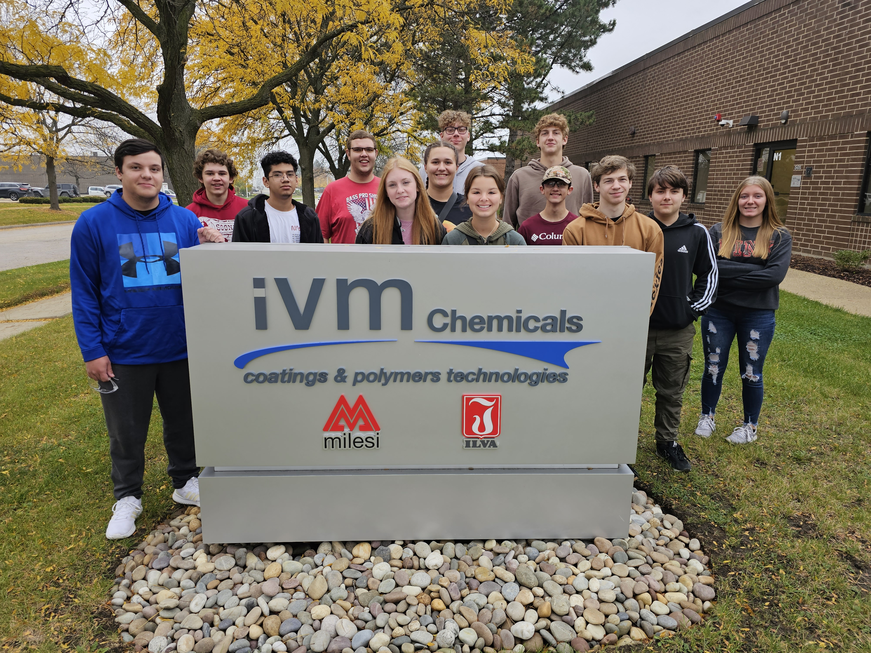

IVM Chemicals is part of the IVM Group, among the world's foremost groups in this sector - considered to be one of the high tech segments in the “Paints and Varnishes” industry, with Companies in the main European Countries and a distribution network in more than 100 Countries. It also manufactures resins, adhesives and polyurethane elastomers.

Program supporters make it possible to offer great educational opportunities to our students. You can visit http://rchsit.weebly.com/program-supporters.html to see all of our program supporters.

Are you looking to build a pipeline for new skilled employees? Contact: mark.smith@rc255.net

