Press Release
February 8. 2024

Lucas Cassidy of Blum/Rev-A-Shelf/Element Designs/Surteco/Custom Accents/Berenson supports Reed-Custer High School’s Industrial Technology Program with Blum Hardware Demonstration.

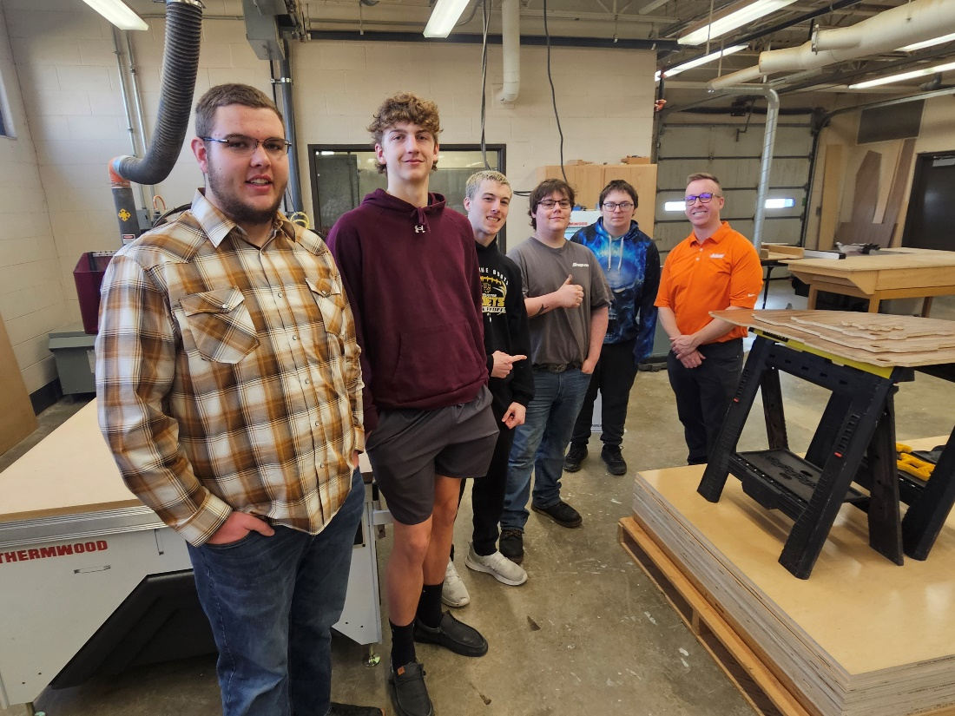
Lucas Cassidy picture with some of your Production students.

Blum stands for quality, innovation and great customer service. We manufacture products such as drawer runners, hinges and lift systems that create an easier workflow for all cabinetry throughout the home. No matter how much things change, our commitment to being part of building a better world will remain steadfast.

Program supporters make it possible to offer great educational opportunities to our students. You can visit http://rchsit.weebly.com/program-supporters.html to see all of our program supporters.

Are you looking to build a pipeline for new skilled employees? Contact: mark.smith@rc255.net

