Press Release
August 22. 2023

Aetna Building Products visits Reed-Custer High School’s Industrial Technology Program with in-kind donation.

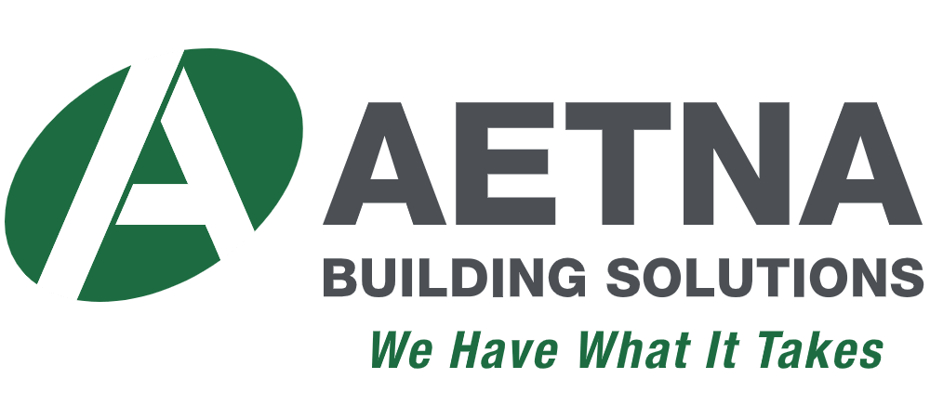

Aetna https://www.aetnaplywood.com is proud to contribute materials to the Reed-Custer High School industrial tech students so they can learn to build and become the craftspeople of tomorrow. It's our hope that we'll see them in the future working at some of our customers or owning their own companies! A special thank you to principal Tim Ricketts and Industrial Tech Instructor Mark Smith for their leadership and partnership with us to make it all possible for their students.

Program supporters make it possible to offer great educational opportunities to our students. You can visit http://rchsit.weebly.com/program-supporters.html to see all of our program supporters.

Are you looking to build a pipeline for new skilled employees? Contact: mark.smith@rc255.net

