Press Release
October 24, 2022

Uneeda Interprizes supports Reed-Custer High School’s Industrial Technology Program with abrasives donation.

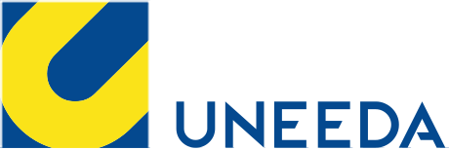

For the past 50 years, Uneeda has been committed to providing the highest quality coated abrasives on the market. Their main objective is to make sure that our customers achieve the best results possible while reducing sanding costs. Their expertise in abrasive products is unique in the industry and they offer sanding technology tailored for your production system. Uneeda is Your Total Sanding Solution!

Program supporters make it possible to offer great educational opportunities to our students. You can visit http://rchsit.weebly.com/program-supporters.htmlto see all of our program supporters.
Contact: mark.smith@rc255.net

