Press Release
November 9. 2023

Stanley Black & Decker supports Reed-Custer High School’s Industrial Technology Program with Tools Donation.
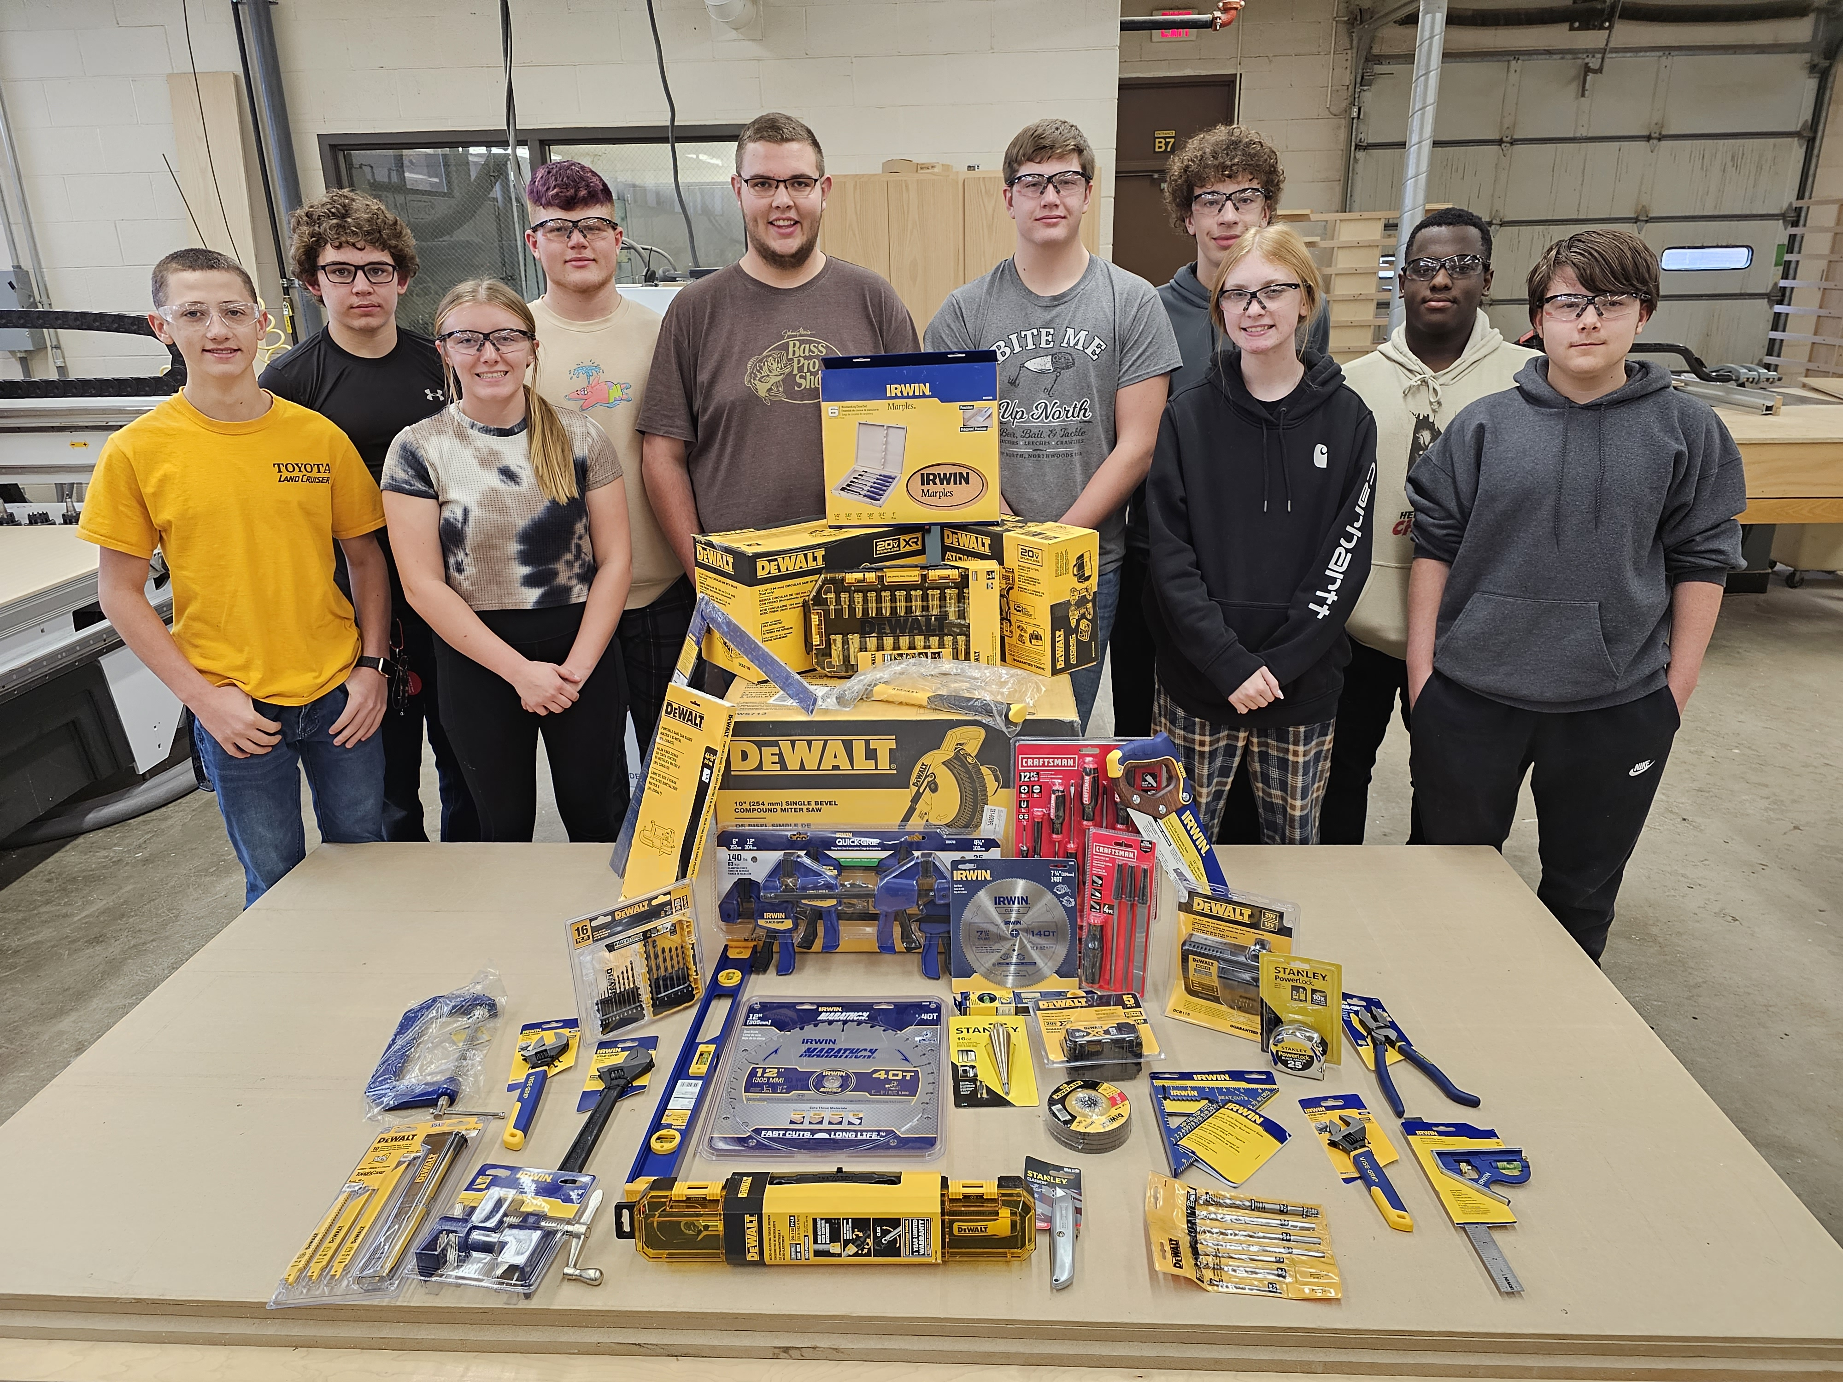

Headquartered in the USA, Stanley Black & Decker provides the tools and innovative solutions you can trust to get the job done – and have since 1843. You know the tools we make that become household names – and jobsite essentials. Brands like DEWALT, BLACK+DECKER, CRAFTSMAN, STANLEY, Cub Cadet, Hustler and Troy-Bilt. But that’s only the beginning. As the first name in engineered fastening systems, they help keep your car secure and mobile phone intact. As a global leader in industrial solutions, they provide the infrastructure systems that reinforce the roads you drive on, build the bridges you cross and even deliver the energy that powers your life. At the end of the day, what they really build is trust. The trust of our customers, our employees, our communities and our stakeholders.

No matter how much things change, our commitment to being part of building a better world will remain steadfast.
Program supporters make it possible to offer great educational opportunities to our students. You can visit http://rchsit.weebly.com/program-supporters.html to see all of our program supporters.

Are you looking to build a pipeline for new skilled employees? Contact: mark.smith@rc255.net

