Press Release
January 27, 2023

M. Bohlke Corporation supports Reed-Custer High School’s Industrial Technology Program with in-kind donation.

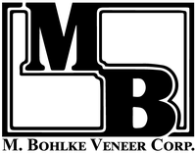

The dedicated team at M. Bohlke Veeer Corporation www.mbveneer.com is composed of wood lovers, many of whom have devoted their entire careers to the wood industry. Many of them are woodworkers with decades of experience. They love the beauty of wood, the story of wood, and the things they can make with it. From our manufacturing team, who ensure we slice high quality veneer, the sales team, who pair the perfect aesthetic to custom projects across the globe, the strong love and passion for wood is found within every square inch of our facilities.

Program supporters make it possible to offer great educational opportunities to our students. You can visit http://rchsit.weebly.com/program-supporters.html to see all of our program supporters.

Are you looking to build a pipeline for new skilled employees? Contact: mark.smith@rc255.net

