Teacher of the Year 2016

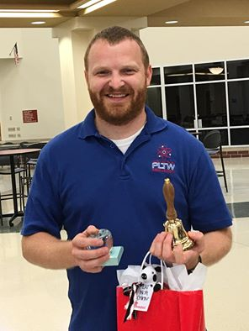

Chris Hill
May 27 at 7:35pm · Plainfield, IN ·
Today I received an award that I never thought I would even be considered for, Teacher of the Year at Avon High School. Warning: This post is going to be long. I have a lot of people that I want to recognize as I do not feel as if this award was given to me solely.
First, I want to thank my wife, Jenny Spors Hill who realizes that being a great teacher is far beyond an 8-3 day and supports me through all the late nights, early mornings, and me being gone a lot. Next, I want to thank all the great teachers at Avon High School that push each other to unimaginable levels. There are 130 teachers at the high school, so I won't tag some and not all. Accept for Gary Ayers. You are a good friend, a mentor to me, and the smartest person I have ever met. I would not be the teacher i am without you, Mr. Ayers. It is an honor work alongside you daily. Next, I want to thank my students, I brag about you daily as being the best of the best. You are willing to try new projects, even when they involve crazy things like redesigning the principals desk. I hope someday my two sons will be like you all. Also, I want to thank all the outstanding parents that blindly support me through my teaching and the robotics club. I have never asked you for something and not received it. You believe in me and my program, for that I am thankful. Finally, I would like to thank those individuals that inspired me to become a teacher and showed me what it takes to be a good one. David Murphy that showed me what it takes to be a great teacher in Avon. Mike Hobaugh (no facebook) for showing me how to teach students to take pride in their work and how to be incredibly patient with difficult students. To Oren Sutherlin who showed me how to be the most positive person in a school even when it is very difficult. Tony Coleman who showed me that a teacher that genuinely cares for his students can have a huge impact. Brian Byrum who showed me how to be very stern towards students, but also very caring. Mark Smith who showed me what it takes to have an outstanding Tech Program. Finally, I want to thank my parents, Nancy Hill and Rick Hill that taught me to be the hardest working person in the room, each and every day and great things will happen. There are many more, but I cannot list all here. Sorry this was long.

