Press Release
October 17. 2023

Amana Tools and Pyramid Technical Group supports Reed-Custer High School’s Industrial Technology Program with in-kind donation.
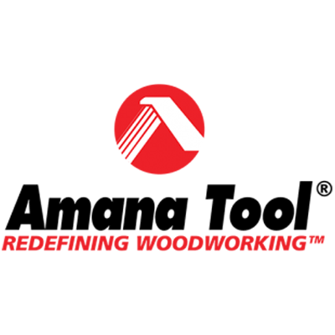

Amana Tool® www.amanatool.com is an industry leader for over 50 years specializing in industrial quality cutting tools, including solid carbide, insert carbide and carbide-tipped tooling, for the woodworking, plastics, aluminum, composite, and metal industries.

Pyramid Technical Group is owned by Lee James, he has been in the woodworking and metalworking industries for 34 years as a distributor rep/owner and a representative of coated abrasive manufacturers. He is now an independent rep in TN for Amana Tools, Uneeda Enterprizes, Cycan Industries, Knape & Vogt and Century Components. He covers several States including IA, IL,IN,KY,MS & TN.

Program supporters make it possible to offer great educational opportunities to our students. You can visit http://rchsit.weebly.com/program-supporters.html to see all of our program supporters.

Are you looking to build a pipeline for new skilled employees? Contact: mark.smith@rc255.net

